Social Studies 30-2 Name: _____________

Perspectives on Ideology
Key Issue: To what extent should we embrace an ideology?

Related Issue #3: To what extent are the principles of liberalism viable?
Chapter 14: Reflecting on the Viability of Liberalism

Chapter Issue: To what extent are the values of liberalism viable in response to issues today?

Chapter Overview:

During the study of Chapter 14, you will investigate how liberal democracies attempt to reach a consensus over the promotion of individual rights—one of the principles of liberalism—within their state, while at the same time attempting to benefit the common good. Sometimes in their pursuit of the common good, governments ignore the rights of individuals or groups.

Nonetheless, the struggle for the recognition of individual liberty and collective rights in legislation and the maintenance of the common good is evident in much government legislation. The tension often experienced by governments trying to balance individual and collective rights with the common good highlights the theme of this chapter.

Questions for inquiry include:
- In what situations should liberal values be limited?
- What challenges can force societies to reconsider liberalism?

Key Terms | Canadian Charter of Rights and Freedoms, American Bill of Rights, enemy aliens, internment, no-fly list, War Measures Act, The Emergencies Act, Anti-Terrorism Act, USA Patriot Act
Key Concepts | emergencies and security legislation, individual rights, collective rights, illiberal, terrorism, respect for law and order, profiling & racism
Key People | Maher Arar, Pierre Trudeau, George Bush, RCMP, CSIS

Introduction (363):
1. Read the Prime Directive. Is it in keeping with liberal values?

- From your glossary, define the War Measures Act in the following paragraph.
365 The War Measures Act gave the federal cabinet _______________ powers for circumstances where it determined that the existence of _______________, _______________, or _______________, real or apprehended, existed. This Act, which suspended civil liberties, was enacted 3 times in Canadian history; 1_______________________________, 2 ________________________________ and 3. ___________________________

- a) (366-7) Define the term enemy aliens.

b) In 1914, immigrants from what countries were considered enemy aliens? Why?

c) List the restrictions and the requirements expected of enemy aliens in 1914.

d) Why do you think the government took these extreme measures?

e) What is the significance of Bill C-331 which was passed into law in 2005?

- a) 367 Why did the Canadian government invoke the War Measures Act during the Second World War?

b) Who was impacted by this decision? How?

- How would you respond to today if such actions occurred in Canada? Why might governments choose to reject the principles of liberalism in some cases?

- The Emergencies Act (368) a) Some say that the government’s actions during an emergency are subject to the _______________________________________. Others say that there is always the risk that our ____________ _____________ may be violated.

b) What are the 4 categories of national emergencies?

- The Anti-Terrorism Act; Dec 2001 (369)
Read the features of the Anti-Terrorism Act.
- Who created the act?

- Why?

- What is the “sunset clause”?

- Name 1 Canadian who was impacted by this act.

- To what extent is the Anti-Terrorism Act placing the perceived common good of citizens above individual rights?

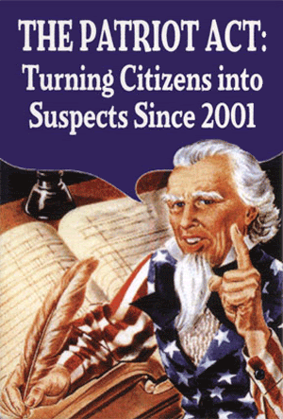

- Limiting Individual Rights: The USA PATRIOT Act (371)

a) What was the catalyst for the introduction of the USA Patriot Act (2001)?

b) The term USA PATRIOT Act is an acronym that stands for what?

c) List the law enforcement activities permitted by the Patriot Act. 370 (Compare the rights of enforcement agencies before & after the Patriot Act was passed)

- Why do opponents believe the act is unconstitutional?

- Statistics, Profiling, & Racism (371)
- What is profiling?

- Have you been victimized by profiling? How?

- How does profiling violate the principles of liberalism?
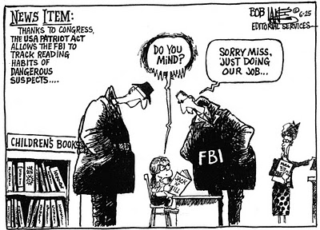

- Canada’s Security Certificates (372)

- Who could be issued a security certificate?

- What is the implication for the individual?

- Why is it difficult to simultaneously protect civil liberties and national security?

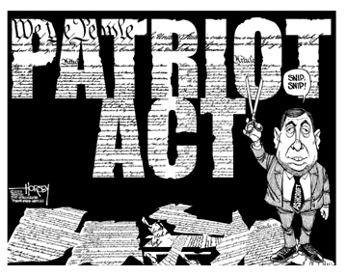
- Explain the significance of the following cartoon.
____________________________
____________________________
____________________________
____________________________
____________________________
____________________________
____________________________
____________________________
____________________________
________________________________________________________________________________________________________________________________________________________________________________________________________________________________________________________________________________________________________________________________________________________________________________________________________________________________________________
Challenges to Liberalism (pg 374)

- Issues that force societies to re-evaluate the values of liberalism are:
- ______________________________________
- ______________________________________
- ______________________________________
- ______________________________________
- ______________________________________

- Define the following terms:
- Poverty

- Poverty line

- Debt

- How were individuals getting loans to buy houses easier than before? (p377)
_____________________________________________________________
- Millenium development goals

- World bank

- Environmental concerns

- Resource use and development

- Arctic countries are: (p381)

- Excessive intrusion (p385)

- Self-interest

- Pandemic

- altruism

