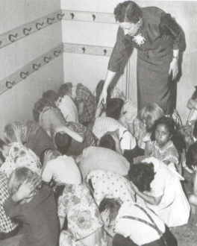

So 2.10 (chapter 8)
Examine how ideological conflict shaped international relations after the Second World War (expansionism, containment, deterrence, brinkmanship, détente, liberation movements)

Task 1: Introduction: Read page 183 introduction and Watch YouTube: 1972 Summit Series Game 8 and Aftermath.

Task 2: Read chapter 8: Ideologies in Conflict: The Cold War

Task 3: Watch the DVD’s on the Cold War (Part I:1945-1961 - 35:00 minutes and Part II:1962-1991 - 35:00 minutes) and attempt to answer the following questions:

- When we use the term Cold War what years are we referring to? 19 ____ to 19 ____.

- What happened on the banks of the Elbe River in April of 1945?

- What did the U.S. represent and defend during the course of the Cold War?

- What did the Soviet Union represent and defend during the course of the Cold War?

- Review how the Cold War between the U.S.S.R. and the U.S. was fought?
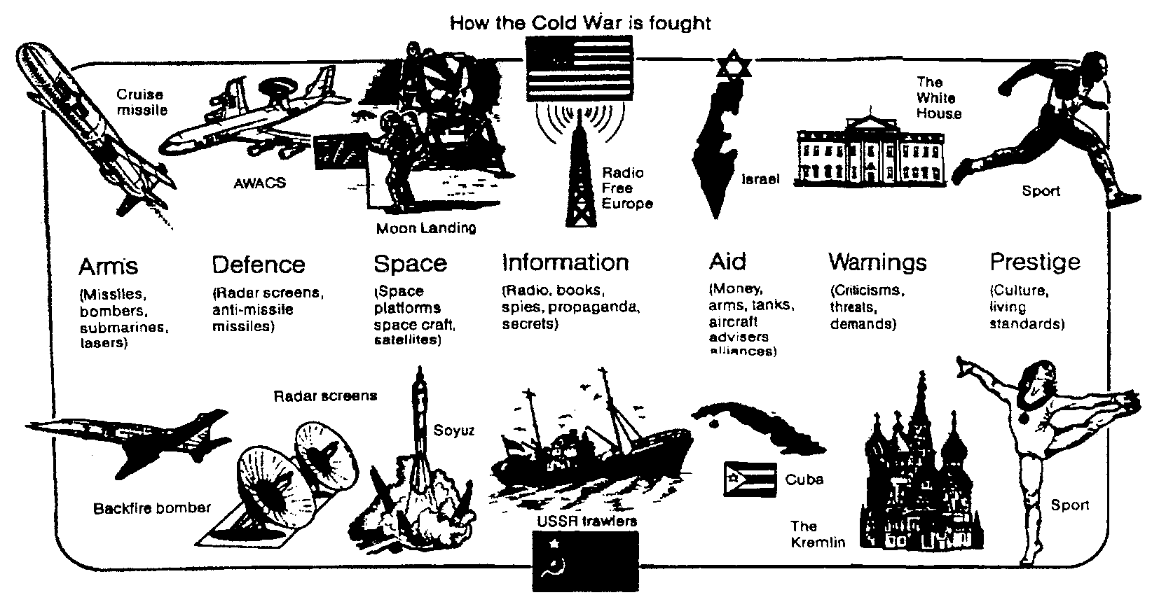

- Use the map to help explain what happened to Germany and Berlin following the war:
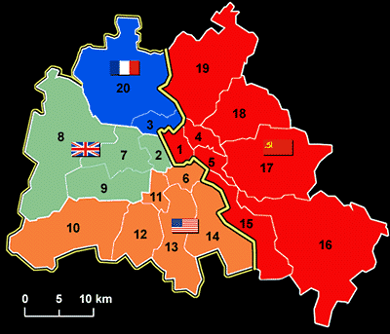
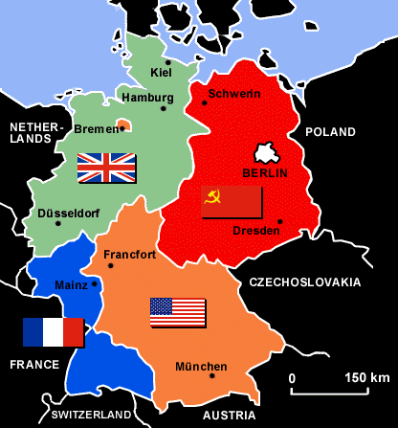
- Explain the maps

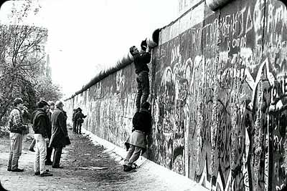

- What does the term containment mean?

- What does the term ‘Iron Curtain’ refer to?

- What was the Truman Doctrine?

- What was the Marshall Plan?

9. Describe the event known as the Berlin Blockade (Airlift).

- What is NATO? It formed in 19 ____.

- What is the Warsaw Pact? It formed in 19 ____.

- Describe the Korean War.

- Who were Sobel and the Rosenburgs?

- What was McCarthyism?

- What did peaceful coexistence refer to? Who implemented it?

- What happened in Hungary in 1956?

- What did the Soviets do in 1958 that shocked the United States?

18. What happened in 1960 that raised tensions between the U.S. and U.S.S.R.?

19. What did the Soviets do in East Berlin in 1961?

20. Describe the Cuban Missile Crisis.

21. Describe the Vietnam War.

22. What does the term détente mean?

23. What happened in Afghanistan in 1979?

24. What did Gorbachev’s policies lead to?

Task 4: Create a Mind map or Timeline of the Key Events leading up to, during and ending the Cold War. Use the following outline of MUST HAVE information to organize your map. Each event needs to be explained/defined to identify the key events of 1945-1989.

- Agreements & Ideologies
- Yalta

- Potsdam

- Expansionism
- Spheres of Influence

- Containment
- Truman Doctrine

- Marshall Plan

- Alliances
- NATO

- Warsaw Pact

- Escalating Tensions
- War of Words

- Prestige War

- Espionage

- Deterrence

- Brinkmanship & the Cuban Missile Crisis

- Proxy Wars
- Korean War

- Vietnam

- Soviet War in Afghanistan

- Reducing International Tensions
- Diplomacy – Ping Pong Diplomacy

- Liberation Movements (Pro-Democracy Movements)
-Hungarian Revolution

-Czechoslovakia

-Poland

-Berlin Wall (Fall of)

- Détente and Treaties
- Nuclear Arms Treaties

-SALT I

-SALT II

Student Rubric: Name_____________________________________

 | Exc  5 marks | Pf  4 marks | Sat  3 marks | Lim  2 marks | Poor  1 mark | INS  0 marks
Content
(x8)

Creativity

Presentation

**Note: Content mark is based on the eight sections of the outline provided in task 4

TOTAL MARK: /50

Teacher/Class Comments:

Task 3:TEACHER VIDEO QUESTIONS KEY********

- When we use the term Cold War what years are we referring to? 19 _45_ to 19 _89_.
- What happened on the banks of the Elbe River in April of 1945?

U.S. and U.S.S.R. soldiers met as allies for the last time on the Elbe River. Soviets had pushed from the East and the Americans, British and Canadians had pushed from the west after D-Day.

- What did the U.S. represent and defend during the course of the Cold War?

They supported an ideology representing democracy, freedom, and capitalism.
- What did the Soviet Union represent and defend during the course of the Cold War?

They supported an ideology representing communism and a more controlled society (dictatorship)

- Review how the Cold War between the U.S.S.R. and the U.S. was fought?

- Use the map to help explain what happened to Germany and Berlin following the war:
Germany was divided into the Eastern sector controlled by the U.S.S.R. and the west which was subdivided into three zones controlled by the U.S., France, and Britain. Berlin was divided the same way.

- What does the term containment mean?
It means stopping something from expanding or growing. In the Context of the Cold War it was the U.S. policy to ‘contain’ the spread of communism – containment.

- What does the term ‘Iron Curtain’ refer to?
It is a term coined by Winston Churchill to describe the eastern European countries under the control of the Soviet Union who had liberated them – satellite countries – buffer zone.

- What was the Truman Doctrine?
U.S. President Harry Truman states that his country will do whatever it takes to keep people free. It was his policy of containment - to stop the spread of communism.

- What was the Marshall Plan?

U.S. economic plan to rebuild Europe. The idea was to help countries out before the post-war economic depression led to unrest and political extremism.

9. Describe the event known as the Berlin Blockade (Airlift).
Soviets try to block the flow of needed resources (food, fuel etc.) into West Berlin to test the resolve of the allies. The U.S. and Britain organize a massive airlift to supply West Berlin. The Soviets eventually back down

- What is NATO? It formed in 19 _49_.
NATO is the North Atlantic Treaty Organization. It was created as a Cold War military alliance between Canada, U.S., Britain and other Western European nations.

- What is the Warsaw Pact? It formed in 19 _55_.
It was created as a Cold War military alliance in response to NATO. It was led by the Soviet Union and included all of the Eastern European satellite countries – ‘iron curtain’.

- Describe the Korean War.
Communist North Korea (backed by the Soviets and the Chinese) invades South Korea in 1950. UN led coalition of 32 nations (including Canada, U.S., Britain) come to the aid of South Korea. Eventually the dispute is settled along the 38th parallel where a de-militarized zone (DMZ) is set up. The DMZ is still in place today.

- Who were Sobel and the Rosenburgs?
They were spies caught giving nuclear secrets to the Soviets. They were executed.

- What was McCarthyism?
U.S. Senator Joseph McCarthy spreads paranoia and fear about communism in the U.S. government (‘Reds’ ‘Commies’). He eventually resigns after ruining political careers.

- What did peaceful coexistence refer to? Who implemented it?
It is a term used by Khrushchev to describe his arrogant belief that communism would soon rule the world, so why not just get along with the U.S..

- What happened in Hungary in 1956?
There is an anti-communist uprising in Hungary. Khrushchev decides to send in the tanks and brutally crushed the uprising. It sends a powerful message to the satellite countries. The same situation unfolds in 1968 in Czechoslovakia and Brehznev takes the same course of action. Outcome is less brutal, but send the same message.

- What did the Soviets do in 1958 that shocked the United States?
The Soviets launch ‘Sputnik’, the first satellite. This scares the U.S. because it displays new missile technology that could potentially attack the U.S.

18. What happened in 1960 that raised tensions between the U.S. and U.S.S.R.?
U.S. U2 spy plane is shot down over Russian soil. U.S. caught spying!

19. What did the Soviets do in East Berlin in 1961?
They built the Berlin wall to stop East Berliners and East Germans from going to live in West Berlin, which was recovering much faster than the East. It was embarrassing.

- Describe the Cuban Missile Crisis.
U.S. discovers Soviet missile bases in Cuba. U.S. places a naval quarantine around Cuba. U.S.S.R. refuses to back down and serious threats go back and forth – brinkmanship. A deal is eventually struck but it is the closest the world has come to a nuclear war.

- Describe the Vietnam War.
Communist North (backed by the U.S.S.R.) infiltrates the Southern portion of Vietnam along the famous Ho Chi Mihn trail to spread communism. U.S. is scared of the domino effect so they slowly get involved helping the South. Eventually they are totally caught up in the war and it becomes a huge military and domestic disaster – they pull out in 1975.

22. What does the term détente mean?
The term means a relaxation in tension between two sides. There were times when the superpowers did meet and agree to things (Non-Proliferation Treaty, SALT I and II etc.)

23. What happened in Afghanistan in 1979?
Soviets invade Afghanistan in 1979. They try to prop up a communist government. The war becomes very costly for them and they eventually withdraw in 1988. It becomes a military and domestic disaster for them – similar to Vietnam for the U.S.

24. What did Gorbachev’s policies lead to?
Perestroika was a complete economic restructuring of the economy to allow for some private property and incentive. Glastnost was allowing for openness and democracy. Once Soviet citizens got a taste of these things there was no turning back – U.S.S.R. dead in 1992.

