Chapter 6 & 7 Review of Terms
Social 20-2
So 2.7…examine similarities and differences between nationalism and ultranationalism
So 2.8 analyze nationalism and ultranationalism during times of conflict (causes of WWI WWII, examples in WWI WWII, internment in Canada, conscription crisis.

Define the following terms:
Term/person | Example/explanation
- nationalism

- Ultranationalism

- Propaganda

- Inflation

- Charisma

- Kristallnacht

- Appeasement

- Czechosolvakia

- Failure of the League of Nations

- Censorship

- Conscription

- Internment camps

- Peacekeeping as a response to Ultranationalism

Hitler & Ultranationalism in Germany.
Categorize the terms/ phrases below into 4 categories to sort out the ideas….be prepared to explain…
Charismatic, inspired enthusiasm, devoted followers, promised he would restore Germany’s national pride, skilled speaker, refused to recognize the Treaty of Versailles, rebuilt the country’s armed forces, reclaimed territories lost at the end of WWI, Aryan race, Nazi propaganda, mass rallies,” Today Germany...Tomorrow the whole world.”, Third Reich, racial policies to eliminate inferior people, history books rewritten to Hitler’s perspective, night of broken glass, appeasement/Czechosolvakia, Goebbels, depression.

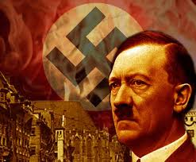

Stalin & Ultranationalism in Russia
Categorize the terms/ phrases below into 4 categories to sort out the ideas….be prepared to explain…
Unemployment, poverty, absolute monarch, civil war, USSR, Stalin, collectivization of farms, 5 year plans, Siberia, Ukranian farmers, political prisoners, slave labour camps, propaganda, name calling, caring father of the Soviet People,

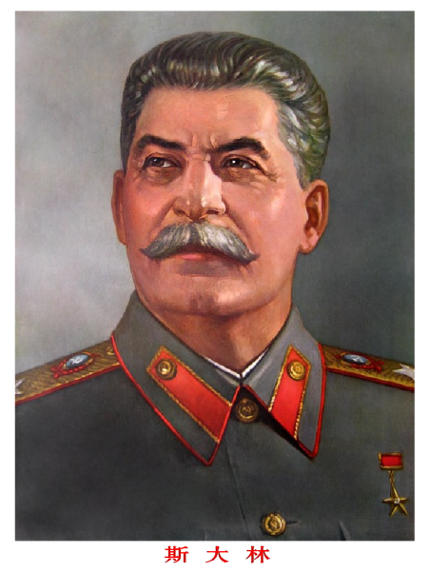

Chapter 7 Key terms….define and provide an example.
Term/person | Example/explanation
- Genocide

- War crimes

- Crimes against humanity

- Nanjing Massacre

- Armenian Genocide

- Ukrainian Genocide

- Hiroshama

- Nagasaki

- Truman

- Enola Gay

- ICC

- Ethnic Cleansing

- ICC

- Milosovic

- Rwanda

