Final Exam Review – “The Stuff you really need to know…”
Social 30-2

Task: Complete the following outline by creating either a mind-map, notes or flashcards on the key ideas.
Include: definitions, key ideas, and historical/contemporary examples.

- RI#1 – Identity & Ideology
Chapter 1-3: Individualism & Collectivism
Principles of Individualism | Principles of Collectivism

Define:
Belief=___________________________________________________________________
Value=___________________________________________________________________
Ideology=_________________________________________________________________
Crown Corporation= ________________________________________________________

PHILOSOPHERS: What are they known for/ quotes etc. 3 things……
Hobbes:

Locke:

Rousseau:

John Stuart Mill:

- RI#2 – Challenges to Liberalism
Chapter 4 – Roots of Liberalism

Haudenosaunee Confederacy – why are they important to the development of Liberalism?___________________________________________________________________________________________________________________________________________________

ADAM SMITH – What are his key economic ideas? List and explain.

John Stuart Mill…who is he and why is he important to know in relation to Liberalism?

In a few sentences explain the difference between Classical Liberalism and Modern Liberalism;_________________________________________________________________________________________________________________________________________________________________________________________________________________________________________________________________________________________________________________________________________________________________________________________________________________________________________________________________________________________________________________________________________________________________________________________________________________________________________________________________________________________________________________________________________________________________________________________________________________________________________________________________________________

Chapter 5 – Impacts & Responses to Classical Liberalism
Define:
Laissez-faire capitalism: ______________________________________________________
Industrial Revolution: ________________________________________________________
Child Labour: _______________________________________________________________
Welfare State: _______________________________________________________________
Define:

Radical Liberal Moderate Conservative Reactionary

Chapter 6 – Responding to Liberalism

Socialism/Democratic Socialism defined means:________________________________________________________________________

Karl Marx Owen

Fourier

Tommy Douglas……is the father of _____________ in Canada.

- CCF –what is it?

Chapter 7 – Rejecting Liberalism

Leninism/Russia/Stalin COMMUNISM | Hitler/Germany  NAZISM
Bolsheviks -  Dictatorship -  Putin -  5 year plans | Social Darwinism -  Why did people follow Hitler?

What Techniques do dictators use to hold on to power? List and define.

Chapter 8 – Cold War
YALTA & POTSDAM = ____________________________________________________________
Draw the mind map on page 197 to list and explain cold war strategies… provide an example of these – contemporary and/or historical.

Chapter 9 – Imposing Liberalism

Aboriginals | Other Nations (provide eg)
Haudenosaunee | Self - Interest
Red Paper | Economic
White Paper | Humanitarianism
Indian Act | Afghanistan

Chapter 10 – Is Resistance to liberalism justified?

What ways of thinking have challenged liberalism in Canada and explain

- RI#3 – The Viability of Liberalism
Chapter 11 – Democracy in theory and practice
Will of the people means____________________________________________
How do democratic governments recognize the will of the people?
Idea - define | Explain & provide examples…
Voting & the electoral process

Referendums & plebiscites

Consensus Decision Making

Interest Groups

Protests and riots

Political & Economic Grid: Label the quadrants: Communism, Fascism, Democratic Capitalism, Democratic Socialism
Political Freedom

Economic control Economic freedom

Political Control

- What is the difference between Communism & Fascism? (use the grid on previous page) ______________________________________________________________
- What type of democracy is Canada – direct or representative?
- Define first past the post_______________________________________________
- Define proportional representation and what countries use this voting system?
- What is Amnesty Internationalism and draw the symbol for Amnesty International.____________________________________________________________________________________________________________________________________________________________________________________________________________.
Explain the events when Canada disregarded the ‘will of the people’.
- Conscription: _______________________________________________________________________________________________________________________________________________________________________________________________________________
- The War Measures Act: _______________________________________________________________________________________________________________________________________________________________________________________________________________
- The Emergencies Act: _______________________________________________________________________________________________________________________________________________________________________________________________________________
- The Anti-terrorism Act: _______________________________________________________________________________________________________________________________________________________________________________________________________________

Define:
Absolute monarchy ________________________________________________________________
Minority tyranny __________________________________________________________________

Chapter 12 – Exploring Economic Equality
Egalitarianism = ______________________________
Place the following terms on the continuum below: communism, classical liberalism, command economy, high, low, Free-market economy, modern liberalism, democratic socialism, mixed economy, individualism, collectivism.

Degree of Government Involvement in the Economy

How would a Mixed, Free-market and a Command economy respond to the economic question?
Questions | Command (left) | Mixed (center) | Free- market (right)
- What will be produced?

- How will goods and services be produced?

- To whom will goods and services be produced?

- Who will make these decisions?

Fiscal policy= ________________________________________________________
Monetary policy = ____________________________________________________
Describe Sweden’s approach to economic equality (preschool, daycare, health care, education, economy ___________________________________________________________________________________________________________________________________________________________________________________________________________________________________________________________________________________________________________________________________________________________________________________________________________________________________________________________________________________________________

- What is an example of a direct tax? ______________________________________
- What is an example of an indirect tax? ___________________________________

- Explain Canada’s Social Safety Net ____________________________________________________________________________________________________________________________________________________________________________________________________________________________________________________________________________________________________________________________________________________

Chapter 13 – Exploring Government Choices and Liberalism
Explain how the 3 areas of the Canadian Government that have been challenged (as democratic).

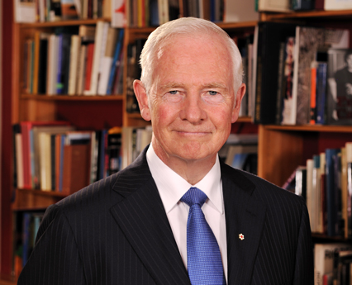

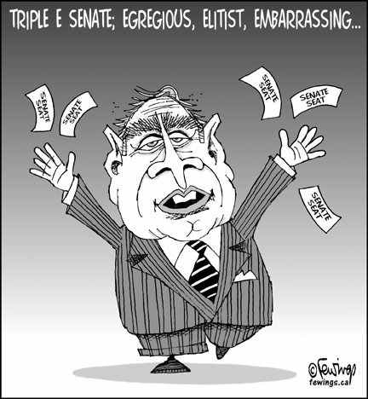

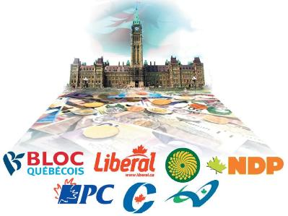

Charter of Rights and Freedom – list and explain rights and freedoms/sections _________________________________________________________________________________________________________________________________________________________________________________________________________________________________________.
Define Canada’s Multiculturalism act ______________________________________________________________________________________________________________________________________________________________________________________________________________________________________.

Chapter 14 – Reflecting on the Viability of Liberalism

Who is this guy and what is his deal…..
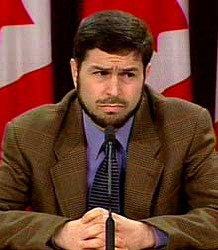
Challenges to liberalism in Canada…explain
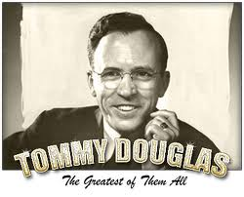 eg. ___________________

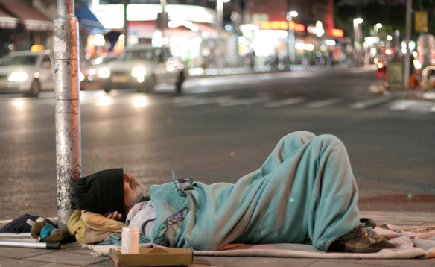
e.g. ________________
e.g. ________________

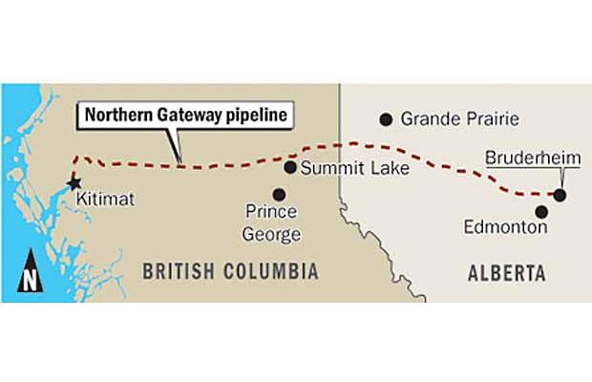 e.g. ________________

- IV. RI#4 – Ideology & Citizenship: Acting for Change
Chapter 15 – Reflecting on Ideology & Citizenship
Explain the following historical and contemporary Pro-democracy movements

- Orange Revolution

- Hungarian Revolution (1956)

- Libya

- Egypt

- Myanmar (Burma)

Chapter 16- Taking Action
Define citizenship - ____________________________________________________________________________________________________________________________________________________________
List 5 ways that you can be an active citizen

Common English words on your diploma exam
- Opponent
- proponent
- Ironic

Hope you do really well on your diploma exam!!!

