INSIDE CSIS
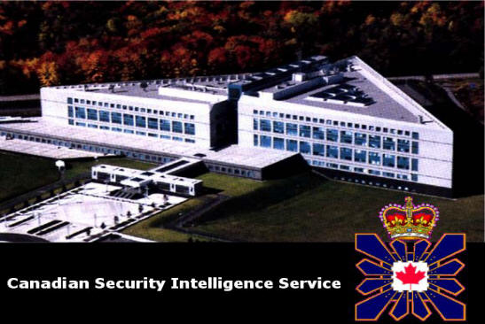

Our Priority Areas
CSIS programs are aimed at investigating and reporting on threats to the security of Canada.

Priority Areas
- Security Screening
- Terrorism
- Proliferation of Weapons of Mass Destruction
- Espionage and Foreign Interference
- Information Security Threats
Security Screening: Assisting the Government of Canada in preventing individuals who pose a threat to the security of Canada from either entering or obtaining status in this country; and in preventing individuals who pose such threats from obtaining access to sensitive government sites, assets or information. Security Screening serves as a first line of defence against both extremism and terrorism, as well as against espionage and the proliferation of weapons of mass destruction. In certain cases, Security Screening also provides security assessments to provincial governments, foreign governments and internationals organizations.
Terrorism: Investigating the threat or the use of violence against persons or property for the purpose of achieving political, religious or ideological objectives.
Proliferation of Weapons of Mass Destruction: Investigating a growing number of foreign states and terrorist organizations that seek to develop and produce weapons of mass destruction, including chemical, biological, nuclear, and radiological weapons.
Espionage and Foreign Interference: Investigating clandestine activities by foreign governments that put Canada's national security at risk; that monitor, manipulate, threaten, or exploit expatriates now residing in this country; that may be detrimental to Canada's scientific and technological developments; that may harm our country's critical economic and information infrastructures or that may affect our military, commercial interests, and classified government information.
Information Security Threats: Investigating threats against critical information systems and infrastructure posed by foreign countries, terrorists, and hackers.

Task 1: 3 Interesting ideas presented in the video and an explanation of why they are interesting: (choose something you learned or concerned you in the video) (6 marks)

Task 2: Label the IMPLICIT message for each cartoon and identify how this may infringe on Liberal values.

