Socialism & Marxism as a Response to Liberalism
Social 30-2
Chapter 6
So2.7 Examine ideologies that developed in response to liberalism (socialism, Marxism)

Task 1: Read introduction in the textbook page 141. Read and listen to Workingman’s Blues #2.
Workingman’s Blues #2
November 05 2009 Canton Ohio Civic Center (youtube)
By Bob Dylan
(speaks about how frustrated people can become when they work hard but cannot change their political, economic and social circumstances for the better).
There's an evenin' haze settlin' over town
Starlight by the edge of the creek
The buyin' power of the proletariat's gone down
Money's gettin' shallow and weak
Well, the place I love best is a sweet memory
It's a new path that we trod
They say low wages are a reality
If we want to compete abroad
My cruel weapons have been put on the shelf
Come sit down on my knee
You are dearer to me than myself
As you yourself can see
While I'm listening to the steel rails hum
Got both eyes tight shut
Just sitting here trying to keep the hunger from
Creeping it's way into my gut
[Chorus:]
Meet me at the bottom, don't lag behind
Bring me my boots and shoes
You can hang back or fight your best on the frontline
Sing a little bit of these workingman's blues
Well, I'm sailin' on back, ready for the long haul
Tossed by the winds and the seas
I'll drag 'em all down to hell and I'll stand 'em at the wall
I'll sell 'em to their enemies
I'm tryin' to feed my soul with thought
Gonna sleep off the rest of the day
Sometimes no one wants what we got
Sometimes you can't give it away
Now the place is ringed with countless foes
Some of them may be deaf and dumb
No man, no woman knows
The hour that sorrow will come
In the dark I hear the night birds call
I can feel a lover's breath
I sleep in the kitchen with my feet in the hall
Sleep is like a temporary death
[Chorus]
Well, they burned my barn, and they stole my horse
I can't save a dime
I got to be careful, I don't want to be forced
Into a life of continual crime
I can see for myself that the sun is sinking
How I wish you were here to see
Tell me now, am I wrong in thinking
That you have forgotten me?
Now they worry and they hurry and they fuss and they fret
They waste your nights and days
Them I will forget
But you I'll remember always
Old memories of you to me have clung
You've wounded me with your words
Gonna have to straighten out your tongue
It's all true, everything you've heard
[Chorus]
In you, my friend, I find no blame
Wanna look in my eyes, please do
No one can ever claim
That I took up arms against you
All across the peaceful sacred fields
They will lay you low
They'll break your horns and slash you with steel
I say it so it must be so
Now I'm down on my luck and I'm black and blue
Gonna give you another chance
I'm all alone and I'm expecting you
To lead me off in a cheerful dance
I got a brand new suit and a brand new wife
I can live on rice and beans
Some people never worked a day in their life
Don't know what work even means
[Chorus]

Task 2: Socialist Values and Early Socialists. Read pages 143-146 to complete the graphics/mindmaps. Write key ideas/concepts around the graphic.

Early socialist...Robert Owen

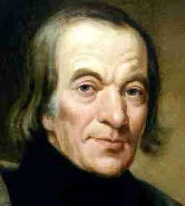

Early socialist...Charles Fourier

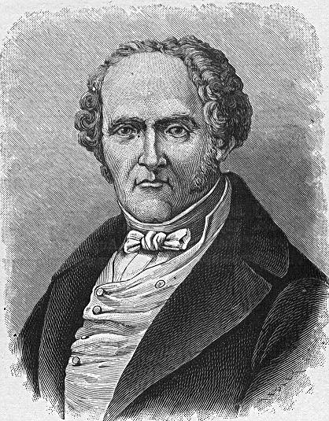

Early socialist...Karl Marx (handout on Karl Marx as well)

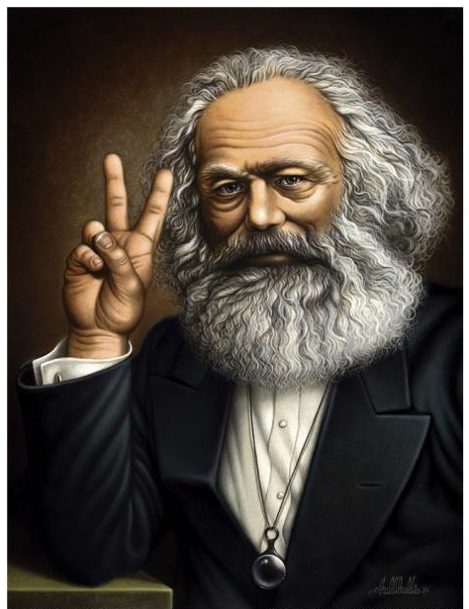

Task 3: Socialism as a Response to Classical Liberalism . Complete the following chart:

Def’n | Values of Socialism  (Collectivism) | Values of Classical Liberalism  (Individualism) | Def’n
 | Humans should be co-operative, helpful and compassionate | Individuals should act in their own interst.
 | Gov’t should intervene in the economy to ensure a more equitable distribution of wealth among citizens | Individuals should be responsible for their own well-being
 | Gov’t should own major industries and run them on behalf of the people. Profits should be kept by the gov’t and then redistributed throughout society | Individuals should have the right to own, buy or sell property.
 | People should work together to achieve collective goals. | Competition benefiets society when people work in their own self-interest, leading to innovation, motivation and lower prices.
 | People should follow rules and norms that benefit society. Society should be structured so that equality exists | No one is above the law, and each indifidual is accountable to the law.

Task 4: Source Analysis - provide the implicit, explicit, perspectives of each source.

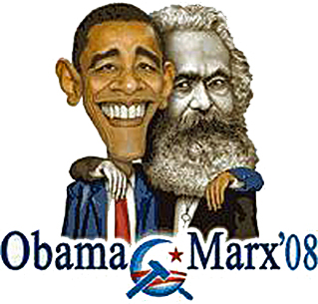

The worker of the world has nothing to lose, but their chains, workers of the world unite.
Karl Marx

Task 5: Define the following terms:
- Vocabulary: Socialism
Find or create a visual image (e.g. cartoon, picture, drawing etc.) to represent the term | Book definition: | Personal Definition (put it in your own words)
Apply the term in a sentence (in context) | What is it not? (opposite terms) | Synonyms (similar terms)

- Vocabulary: Marxism & Communism
Find or create a visual image (e.g. cartoon, picture, drawing etc.) to represent the term | Book definition: | Personal Definition (put it in your own words)
Apply the term in a sentence (in context) | What is it not? (opposite terms) | Synonyms (similar terms)
- Vocabulary: Utopian Socialism
Find or create a visual image (e.g. cartoon, picture, drawing etc.) to represent the term | Book definition: | Personal Definition (put it in your own words)
Apply the term in a sentence (in context) | What is it not? (opposite terms) | Synonyms (similar terms)
- Vocabulary: Democratic Socialism
Find or create a visual image (e.g. cartoon, picture, drawing etc.) to represent the term | Book definition: | Personal Definition (put it in your own words)
Apply the term in a sentence (in context) | What is it not? (opposite terms) | Synonyms (similar terms)

Task 6: Examples of Democratic Socialism in Canada
- Read pages 151-152
- Watch the Video: The Great Depression. List 7 key ideas summarizing the event.

The Great Depression

Task 7: Using pages 152-153 of your textbook, analyze the following sources.

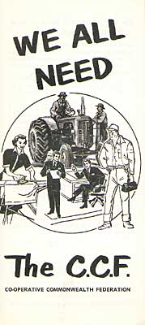
What?

Where?

Who?

When?

Why?

Implicit Message of the Sources?
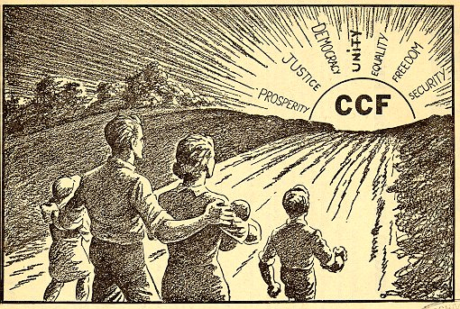
Task 8: Read pages 153-154 in textbook and fill in the blanks....
Rise of Socialism in Quebec
After WWII, Quebec was led by Premier __________. He was strongly anti-communist and anti-union and promoted ____________________ economic policies. He often was accused of____________ individual rights and freedoms of Quebec _________________. During his leadership, the Quebec gov’t _____________ its role in the economy and infrastructure projects. Duplessis died in _______________. Quebec saw a rise in _________________ which was tied to a growing movement supporting the _______________________ of Quebec. The Canadian Government represented an ___________________ force. By the early __________, parties that embraced _____________ values came to power in the provincial government of Quebec. Under Premier Jean Lesage, greater access to _____________ care, education and family allowance occurred. This rise in ________________ during this period of Quebec history was known as the _____________ Revolution, and resulted in the creation of a ___________________ state.
The Parti Quebecois
______________, one of the cabinet ministers in the Lesage government found a new political party, the separatist __________________ Quebecois (PQ), which came to power as Quebec’s provincial government in ______________. Two aims of the party were _______________________ (independence) and also socialist values. In the 1990’s, Quebec’s PQ government introduced government-funded social programs, such as a __________ insurance program, ________________________ to insure the people of Quebec for prescription drugs, a $7.00 a day universal _________________ care system and a generous parental ________________ program.

Task 9: Tommy Douglas - placemat activity:
Watch the DVD – Tommy Douglas (47 minutes)
TOMMY DOUGLAS
The Fight of a Lifetime

Political

Early Years Medicare

War Measures Act

Task 10: Question for Reflection
- In 1962, when the Saskatchewan government tried to bring in the last stage of Douglas’s public health plan, two-thirds of the province’s doctors went on strike. They objected to the idea of a medical plan controlled by the government. How might the battle between the Saskatchewan government and the doctors be seen as a struggle between the practices of classical liberalism and democratic socialism? ___________________________________________________________________________________________________________________________________________________________________________________________________________________________________________________________________________________________________________________________________________________________________________________________________________________________________________________________________________________________________________________________________________________________________________________________________________________________________________________________________________________________________________________________________________________________________________________________________________________________________________________________________________________________________________________________________________________________________________________________________________________________________________________________________________________________________________________________________________________________________________________________________________________________________________________________________________________________________________________________________________________________________________________________________________________________________________________________.

