The Arab Spring is a revolutionary wave of demonstrations, protests, and wars occurring in the Arab world that began on 18 December 2010.
To date, rulers have been forced from power in Tunisia,^{[1]} Egypt,^{[2]} Libya,^{[3]} and Yemen;^{[4]} civil uprisings have erupted in Bahrain^{[5]} and Syria;^{[6]} major protests have broken out in Algeria,^{[7]} Iraq,^{[8]} Jordan,^{[9]} Kuwait,^{[10]} Morocco,^{[11]} and Sudan;^{[12]} and minor protests have occurred in Lebanon,^{[13]} Mauritania,^{[14]} Oman,^{[15]} Saudi Arabia,^{[16]} Djibouti,^{[17]} and Western Sahara.^{[18]} The major oil rich nations (Saudi Arabia, UAE, Qatar, Kuwait and Oman) have been able to keep their ruling families in power.

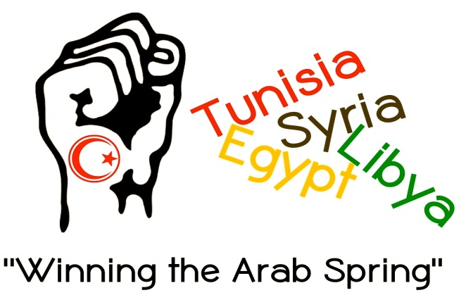
Where: 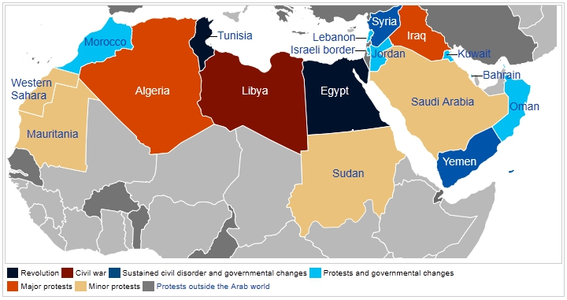
Task: In a group of 4 (maximum) research one of the following nations to describe what occurred in that country during the Arab Spring. Include the 5W’s to create a poster of the event to explain to the class.

